**AI PRODUCT SERVICE PROTOTYPE DEVELOPMENT –**

**RESUME SCREENING**

*TEAM – HIMANSHI*

MEMBERS – 1. HIMANSHI GARG (TEAM LEADER)

2. ARYAN KUMAR

3. P SADHASIVAM

4. KUSHAGRA BHATNAGAR

* ***PROTOTYPE SELECTION***

Finding a perfect job for that fits one’s skills set is a tedious task that almost everyone has to go through multiple times in their lifetime. Applying for jobs online becomes a challenge due to the excess of options available. At the same time, a large number of résumé are submitted for one job posting making the recruitment process for the companies complicated.

A system is needed that can suggest the applicants an appropriate role they should submit their CVs to, and at the same time a system that can filter the CVs received by a company based on the position that seems most apt for them, thus simplifying the recruitment process by screening the CVs for the companies.

The system should be subscription based for the companies that wish to hire employees for vacant positions, and the public can get suggestions for suitable roles to apply for based on the content of the resume

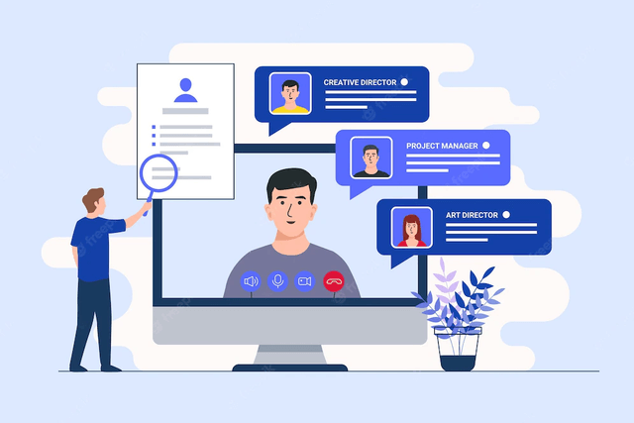

***Feasibility –***

* Automate the Process: Utilize resume screening software or applicant tracking systems (ATS) that use artificial intelligence and natural language processing (NLP) to automate the initial screening of resumes. These systems can quickly analyze and filter resumes based on predefined criteria, saving time and effort for HR teams.
* Define Clear Criteria: Establish clear and specific criteria for the job position. This could include required skills, qualifications, experience, and other relevant attributes. Defining these criteria in advance helps in creating a focused screening process.
* Customize Screening Algorithms: Tailor the screening algorithms of the resume screening system to match the specific needs of the organization and the job position. This customization ensures that the system accurately identifies the most suitable candidates.
* Provide Feedback Mechanisms: Offer clear feedback to applicants if they don't meet the initial screening criteria. This enhances the candidate experience and maintains a positive employer brand.
* Collaborate with Hiring Managers: Involve hiring managers in the screening process to align the criteria with their requirements. Their input can improve the accuracy of the screening system.
* Regularly Update Criteria: Job requirements may evolve over time, so periodically review and update the screening criteria to ensure they remain relevant.
* Test and Optimize: Continuously evaluate the performance of the resume screening system and gather feedback from HR teams and hiring managers. Use the insights to refine and optimize the system's effectiveness.

***Viability –***

Using a viability study, you can determine if a proposed business or project is possible and how likely it is to succeed. Some of these steps could be:

* **Define the project’s or venture’s scope:**

This involves describing the project’s goals, objectives, and deliverables and any restrictions or limitations.

* **Perform a market analysis:**

This entails investigating and evaluating the project or business’s target market, including identifying possible clients, rival businesses, and market trends.

* **Put together a financial plan:**

This includes making a budget for the project or venture, estimating income and costs, and figuring out how much money you expect to make back.

* **Assess risks and uncertainties:**

This entails locating and assessing any potential risks or uncertainties that may impact the project or enterprise, such as governmental changes or market conditions.

* **Prepare a report:**

After the methods above, the data should be compiled into a report that explains the viability study results and offers options for continuing the project or venturing ahead.

* **Review and feedback:**

Distribute the report to the relevant parties and stakeholders, get their input, and make any necessary adjustments.

***Monetization –***

* Identify Target Market: Define your target market clearly. Determine whether you want to cater to specific industries, company sizes, or geographical regions. Understanding your target audience's needs and pain points will help you tailor your system accordingly.
* Develop an Effective System: Create a robust and user-friendly resume selection system that employs advanced technology like natural language processing (NLP) and machine learning to efficiently analyze and rank resumes based on relevant criteria.
* Offer Customization Options: Provide customization options that allow employers to define specific requirements based on their job openings. This flexibility will attract a broader range of clients and increase the system's appeal.
* Implement Data Privacy and Security Measures: Address concerns about data privacy and security. Assure potential customers that their data and the resumes they handle are safe and protected.
* Pricing Model: Offer competitive and flexible pricing models that suit different types of employers, such as subscription-based plans, pay-per-use options, or tiered pricing based on company size.
* Marketing and Promotion: Invest in marketing efforts to raise awareness about your resume selection system. Utilize social media, content marketing, and collaborations with recruitment agencies or job platforms to reach a broader audience.
* Customer Support: Provide excellent customer support to address any questions or issues that potential customers may have. Responsive and knowledgeable support can build trust and encourage adoption.

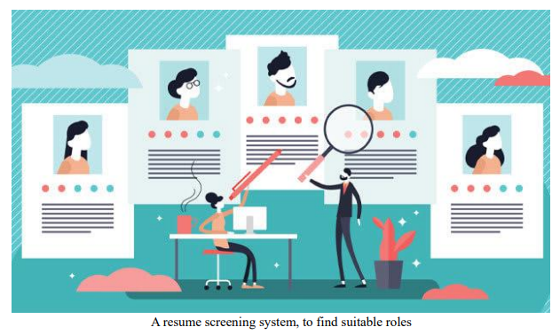

* ***IMPLEMENTATION***

Dataset used: The dataset used for the training of the model was taken form Kaggle. The dataset contains the necessary information (no personal info.) from various resumes and the job domain that they were suitable for.   
The structure of the dataset is:

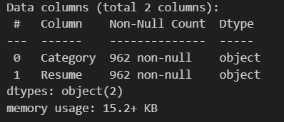

* The various job categories in the dataset are:

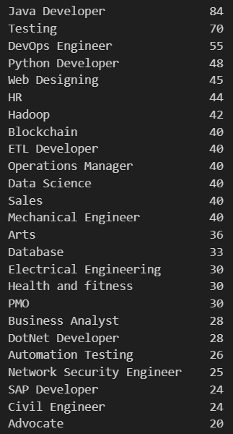

* The text from the resume is cleaned, removing all the special characters, stop-words, URLs, punctuations, etc. and a new column named ‘cleaned_resume’ is added to the dataset.
* Text analysis is performed on the ‘cleaned_resume’ to get a view of the most frequently used words, and get the count-plot of the different job categories.

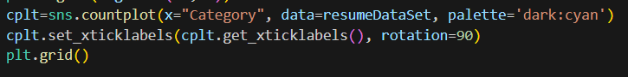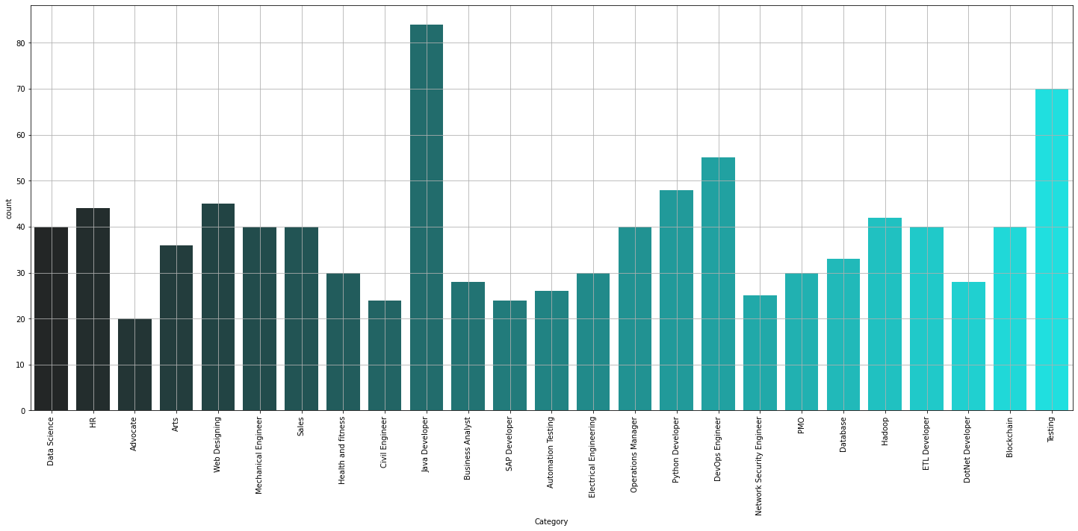

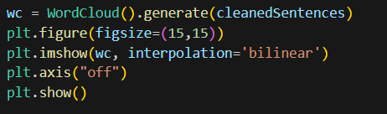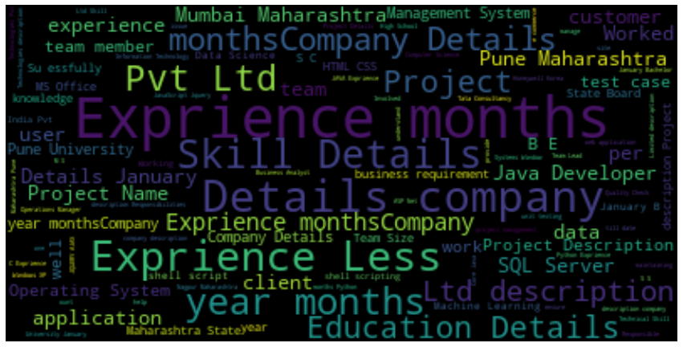

* The categories are encoded using LabelEncoder from sklearn.preprocessing library.
* The text from cleaned resume is vectorized using TfidfVectorizer from sklearn library’s feature_extraction class.
* The categories and cleaned_resume features are fit into 3 machine learning models to compare the accuracy. The 3 models are KNN classifier, Random Forest and naïve bayes classifier.
* The accuracy of these models is:
  + KNN - 95%
  + RF- 98%
  + NB- 89%
* These models are saved as pickle files, to predict the categories of resumes entered by the users.
* The users will be required to create a resume using the application, from those resumes, the necessary information will be passed through the model with most accurate results (Random Forest) and a suitable job category will be suggested to the user based on their experience,
* The GitHub link for the training and testing of the dataset is <https://github.com/Bhatnagar621/Feynn_labs_E_Recruitment>

*Application prototype*

* The application will have two type of accounts, the job seeker and the company.
* A layout for the job seeker is designed using Figma. (Image on next page)
* The user, as job seeker, will be able to perform the following actions:
  + Sign up/Sign in
  + Create/Edit resume
  + Apply for jobs matching their profile
  + Get messages from companies and reply if the company allows
  + Search and explore other job domains
  + Get the skill set that is required for a job
* The company will have the following features:
  + Sign up/Sign in
  + Post job openings
  + Message suitable applicants
  + Screen the resumes using the models and shortlist the best matching applicants
  + Provide feedback to the developers suggesting updates to the machine learning model

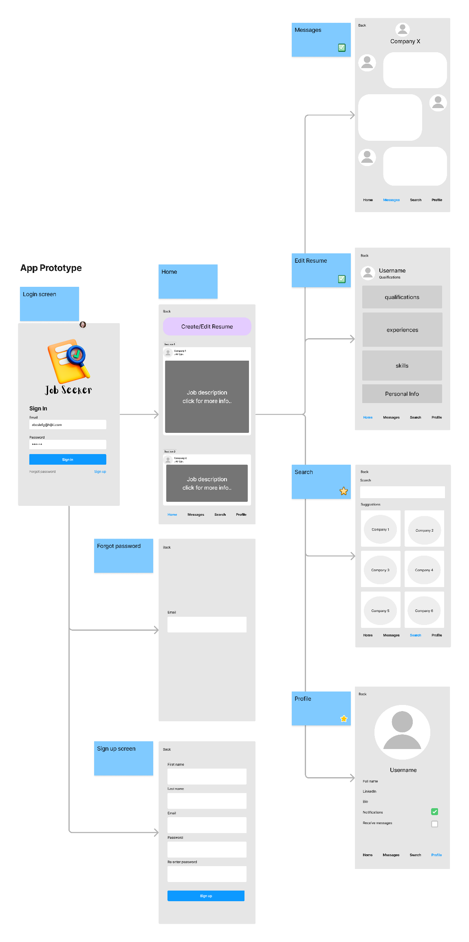

* ***BUSINESS MODELLING***

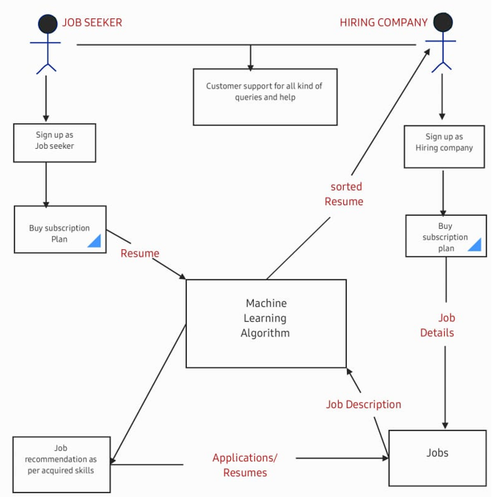

The above diagram gives us the basic idea how our application will be working to generate revenue for us:

* Both the job seeker and hiring company has to signup to the webpage as per their need.
* There will be a free trial made available where they can check for how the whole process will be working but before getting recommendations it is necessary to make them buy subscription plan, so they will be buying plans here as per their need.
* Pricing of subscription plan will be made with consideration that is should be less for job seeker than the hiring companies and should be affordable and economical for both.
* After buying plans individuals will be able to upload their resume to the application based on which algorithm will suggest then they can find relevant job, that is application will be recommending job aspirants with the suitable job as per the skills they have.
* Hiring companies will be able to post their job details along with all the resume received and algorithm will be short listing suitable candidates with most appropriate skills based on their resume.
* Companies will have the flexibility to change the number of shortlisted resumes they want for the job.
* Using this application candidate can also improve their resume by seeing what companies are looking for in a candidate.
* A customer support channel has been created to answer all the queries related to the application and will also be able to help individuals with any part of the application if they need.
* **Applicable Regulations (government and environmental regulations imposed by countries)**
* Data protection and privacy regulations
* Govt Regulations for medium businesses
* Regulations against false advertising
* **Applicable constraints**
* Collection data from both the job seeker and the hiring ones.
* Continuous data connection.
* Updating databases with continuous data collected to make the model more efficient day by day.
* Lack of technical knowledge for the users.
* Figuring out how AI and ML can be implemented for better outputs in small cities where people have less education about technology.
* **Budget**
* Development cost: - It will include all the technical costs such as frontend, database, backend etc;
* Permit and rights: - It involves all the costs to get business rights and permits.
* Promotional cost: - It will include all the advertisement cost.
* Maintenance cost: - It involves all the expenditure that is done to make sure that the application is working smoothly and is up to date.
* ***FINANCIAL MODELLING***

In response to the HR and recruitment market's evolving requirements, our Resume Screening System offers a sophisticated solution that optimizes the hiring process and ensures the best matches for both employers and job seekers.

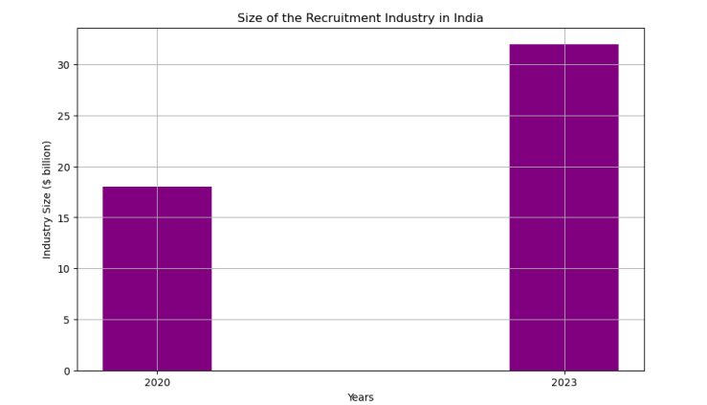

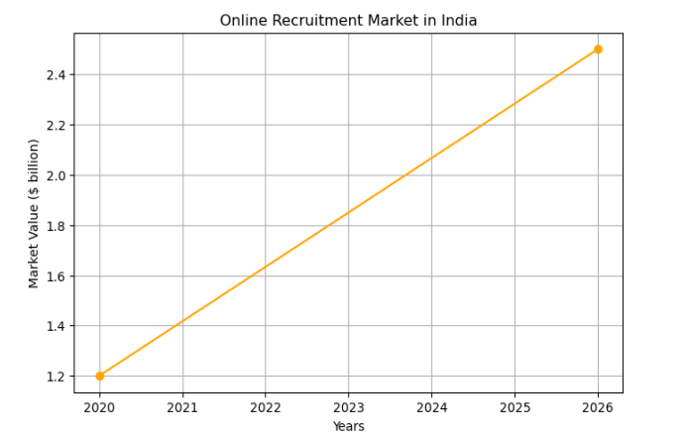

* According to a report by the India Brand Equity Foundation, the online recruitment market in India has been growing at a significant rate in recent years. The report indicates that the market was valued at around $1.2 billion in 2020 and is expected to grow at a compound annual growth rate (CAGR) of around 16% between 2021 and 2026, reaching a value of around $2.5 billion by 2026.
* According to a report from the Indian Staffing Federation, the size of the recruitment industry in India was estimated to be around $18 billion in 2020. This includes both online and staffing firms, as well as temporary staffing and permanent placement services. The industry is expected to grow at a compound annual growth rate of 17.5% between 2020 and 2023, reaching a size of around $32 billion by 2023.

To design a financial equation corresponding to the market trend of the online recruitment market in India, we can use a simple linear equation, considering the growth is projected to be at a constant compound annual growth rate (CAGR) of around 16% between 2021 and 2026

For the online recruitment market, we can represent the market value (y) as a function of time (x) using the CAGR (m) as follows:

y = y0 * (1 + m)^t

where: y0 = Initial market value in 2020 ($1.2 billion)

m = Compound Annual Growth Rate (CAGR) = 0.16

t = Time (number of years from 2020)

To forecast the market value (y) for any year beyond 2026, you can continue to use the equation, where t will be the number of years from 2020.Keep in mind that this is a simplified equation assuming a constant CAGR In any case, the equation above provides a basic starting point for modelling the market trend based on the reports of the online recruitment market's projected growth at a 16% CAGR between 2021 and 2026.

*CONCLUSION*

* Conclusion In conclusion, the e-recruitment project holds potential to change the job search and hiring process.
* By the use of machine learning technologies, the product addresses the challenges faced by both, the job seekers and the companies.
* The developing prototype will be a multiple platform application that will provide job matching, simplified resume screening, effective communication channels and more.
* It will empower the people looking for employment by presenting them with the personalized recommendations over their resumes and help them optimise their resumes.
* Concurrently, it will simplify the recruitment process for the hiring companies by automatic resume screening with the help of its AI.
* Overall, the product will be a promising initiative that will harness the power of machine learning and technology to revolutionize the process of search for jobs and hiring new employees